【CLO_6】

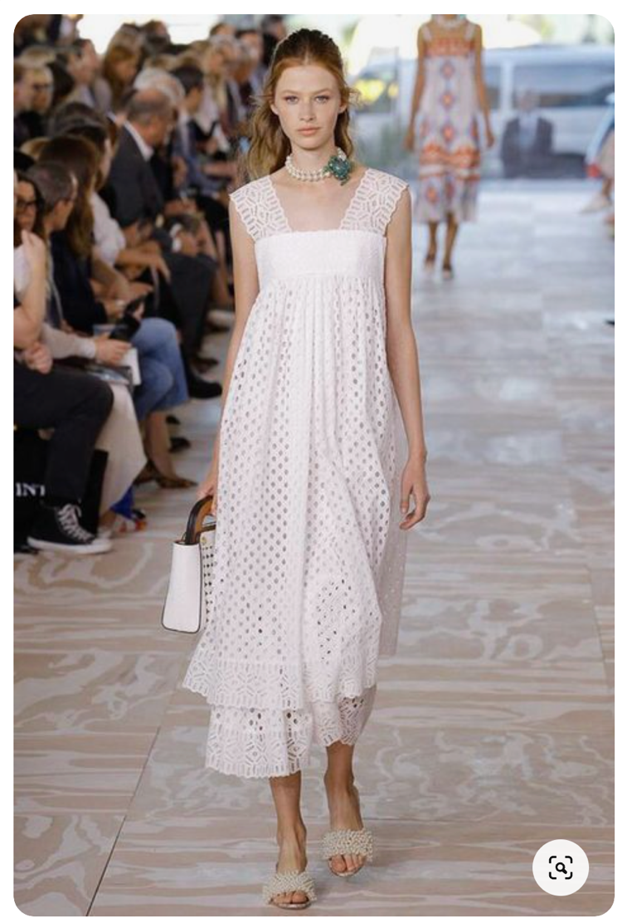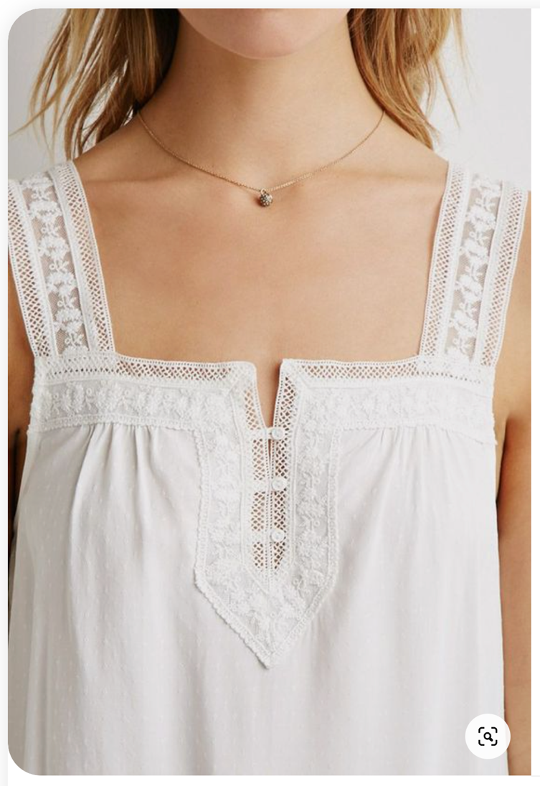

Recreate a dress with two overlapping pieces, as shown in the photo on the left.
The skirt portion of the dress is transparent fabric on the upper side and lace fabric on the lower side as shown in the photo (if the it is transparent, add a beige lining)
Then arrange the shoulder straps and the front center of the dress as shown in the photo on the right.
Wear a necklace like the one pictured below.
